# **IOS Security**

* When a Cisco router or switch is received from the factory no security is configured
* You can access the command line via a console cable with no password required
* One of the first tasks is to configure security to ensure that only authorised administrators can access the device

**IOS Command Hierarchy**

* > = User Exec mode
* # = Privileged Exec moe (“Enable”)
* (config)# = Global Confuration mode (“Configure Terminal”)
* (config-if)# = Interface Configuration mode (“Interface x”)

# **Basic Line Level Security**

* Minimal password security can be configured through the use of static, locally defined passwords at three different levels:
  + Console line – accessing User Exec mode when connecting via a console cable
  + Virtual terminal VTY line – accessing User Exec mode when connecting remotely via Telnet or SSH Secure Shell
  + Privileged Exec Mode – entering the ‘enable’ command
* The levels can be used independently or in combination with each other.
* They can use the same or different passwords.

## **Basic Console Security**

* Only one administrator can connect over a console cable at a time so the line number is always 0.
* ‘Login’ with no following keywords requires the administrator to enter the password configured at the line level to log in  
  + *R1(config)#line console 0*
  + *R1(config-line)#password Flackbox1*
  + *R1(config-line)#login*

Switch Management IP Address

* A Layer 2 Switch is not IP routing aware
* It does however support a single IP address for management
* A default gateway also needs to be configured to allow connectivity to other subnets

*Switch(config)# interface vlan 1*

*Switch(config-if)# ip address 192.168.0.10 255.255.255.0*

*Switch(config-if)# no shutdown*

*Switch(config-if)# exit*

Switch(config)# ip default-gateway 192.168.0.1

## **Basic Telnet Security**

* An administrator can use Telnet to connect to the CLI of a router or switch remotely over an IP connection
* IOS devices do not accept incoming Telnet sessions by default
* An IP address and virtual terminal VTY line access must be configured
* Multiple administrators can connect at the same time. Lines are allocated on a first come first served basis
* If all configured lines are in use then additional administrators will not be able to login

*R1(config)#line vty 0 15*

*R1(config-line)#password Flackbox2*

*R1(config-line)#login*

## **Exec Timeout**

* An administrator will be logged out after 10 minutes of inactivity by default. This applies to both the console and VTY lines
* You can edit this value with the exec-timeout command
* *no exec-timeout* or *exec-timeout 0* allows an administrator to stay logged in indefinitely

*R1(config)#line con 0*

*R1(config-line)#exec-timeout 15*

*R1(config)#line vty 0 15*

*R1(config-line)#exec-timeout 5 30*

## **Securing VTY Lines with Access Lists**

* You can apply an Access List to control access to the VTY lines
* This can be used to limit Telnet and SSH access to only your administrator workstations

*R1(config)#access-list 1 permit host 10.0.0.10*

*R1(config)#line vty 0 15*

*R1(config-line)#login*

*R1(config-line)#password Flackbox3*

*R1(config-line)#access-class 1 in*

## **Basic Privileged Exec Security**

* When you connect over the console or a VTY line you will land at the User Exec prompt which has a very limited set of commands available
* To get superuser access you use the ‘enable’ command to invoke Privileged Exec mode
* This can be secured with a password
* Disadvantage: enable password can be viewed in the show run config

*R1(config)#enable password Flackbox3*

### **Enable Secret**

* An enable secret performs the **same function as the enable password**
* The enable secret is always shown **in an encrypted format** in the running configuration
* If both an enable password and enable secret are configured, the enable secret supersedes the enable password which is no longer used
* **Best practice is to configure an enable secret but not an enable password**

### **Encrypting Passwords**

Line level passwords can also be viewed in plain text in the running configuration by default.

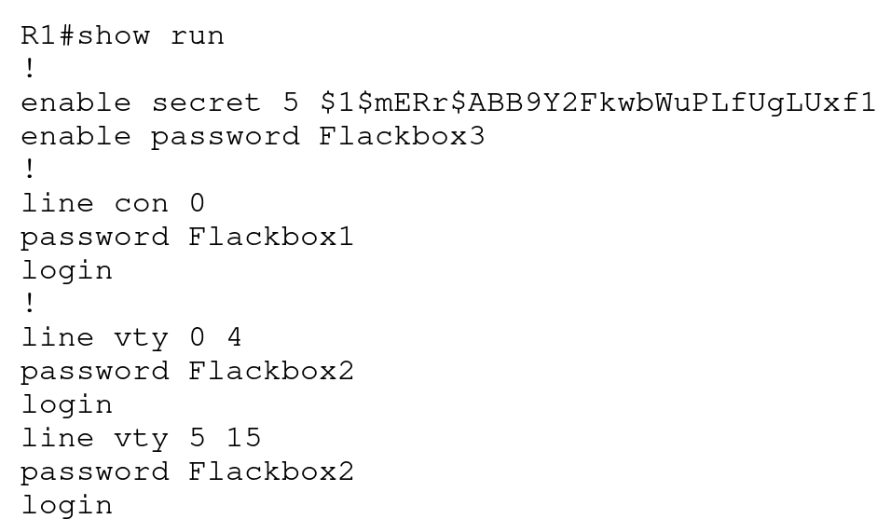

### **Service Password-Encryption**

* The service password encryption command encrypts all passwords in the running configuration
* **It is best practice to enable this**

*R1(config)#service password-encryption*

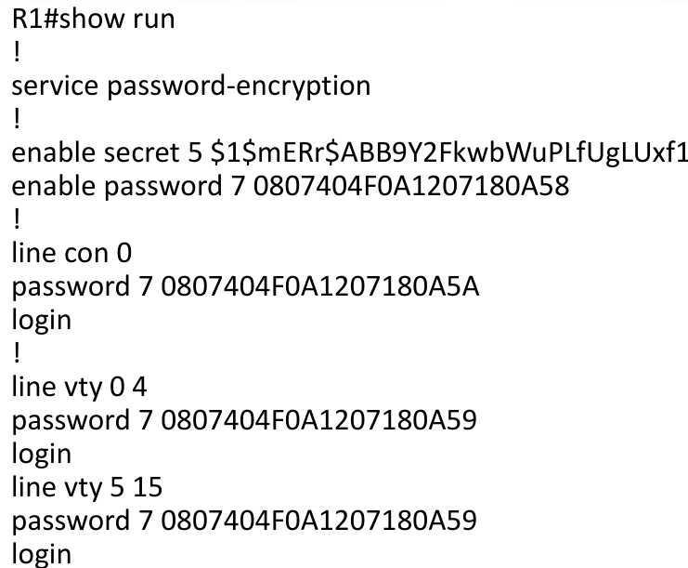

# **Username Level Security**

* 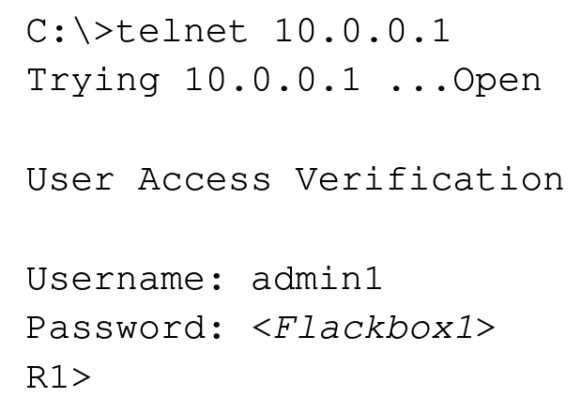More granular security can be provided by configuring individual usernames and passwords for different administrators

*R1(config)#username admin1 secret Flackbox1*

*R1(config)#username admin2 secret Flackbox2*

*R1(config)#line console 0*

*R1(config-line)#login local (use local usernames)*

*R1(config)#line vty 0 15*

*R1(config-line)#login local*

## **Privilege Levels**

* There are 16 privilege levels of admin access (0-15) available on a Cisco router or switch
* Usernames can be assigned a privilege level. The default level is 1.
* You can also configure different passwords for direct access to the different privilege levels
* Each available command in IOS can be assigned a privilege level. An administrator must be logged in with that privilege level or higher to run the command
* By default, three levels of privilege are used - zero, user, and privileged. All commands are at one of these three levels by default
* Zero-level access allows only five commands—logout, enable, disable, help, and exit.
* User level (level 1) provides very limited read-only access to the router. When you enter User Exec Mode you’re at Privilege Level 1 by default
* Privileged level (level 15) provides complete control over the router. When you enter Privileged Exec Mode with the ‘enable’ command you’re at Level 15 by default

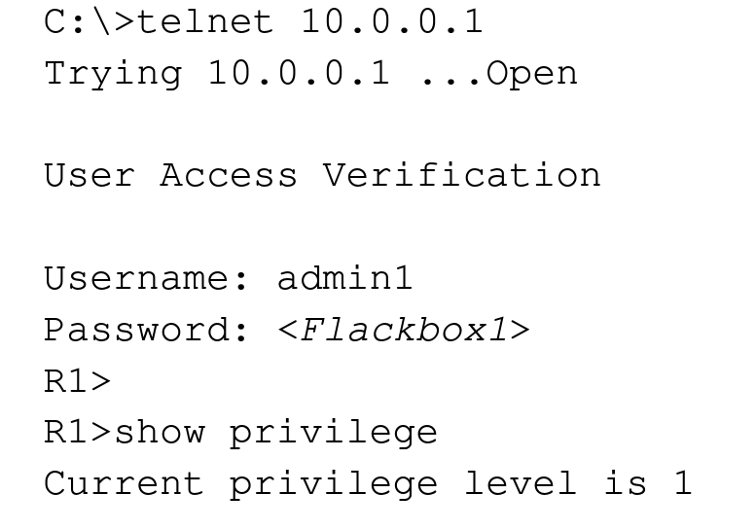

*R1(config)#username admin1 secret Flackbox1*

*R1(config)#username admin2 privilege 15 secret Flackbox2*

*R1(config)#line console 0*

*R1(config-line)#login local*

*R1(config)#line vty 0 15*

*R1(config-line)#login local*

## **Configuring Command Privilege Levels Example**

Only admin2 has *superuser* privileges

*R1(config)#username admin1 secret Flackbox1*

*R1(config)#username admin2 privilege 15 secret Flackbox2*

*R1(config)#username admin3 privilege 5 secret Flackbox3*

Change command privilege level. Now also admin3 can execute *show run conf*

*R1(config)#privilege exec level 5 show running-config*

*R1(config)#enable secret secret1* (sets password for privilege level 15)

*R1(config)#enable secret level 5 secret2* (sets password for privilege level 5)

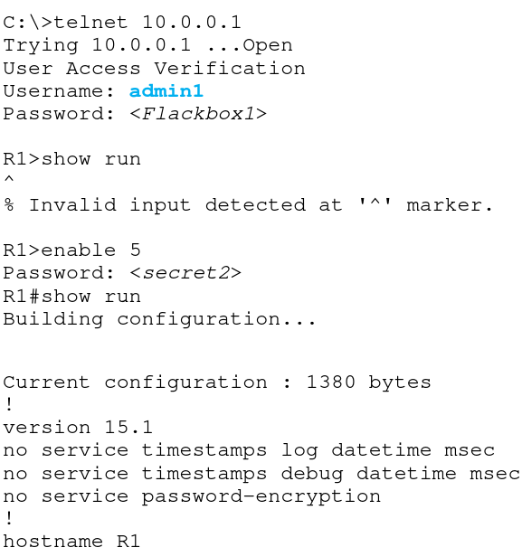

# **Telnet vs SSH**

* All Telnet communications cross the network in plain text
* If somebody sniffs the traffic using a tool such as Wireshark they can see all the commands you enter including your username and password
* All SSH Secure Shell traffic is encrypted
* If somebody sniffs the traffic they cannot read it
* Best practice is to disable Telnet and only allow SSH for administrator CLI access

**Enable SSH**

* A digital certificate with a key length of at least 768 bits must be generated to enable SSH encryption

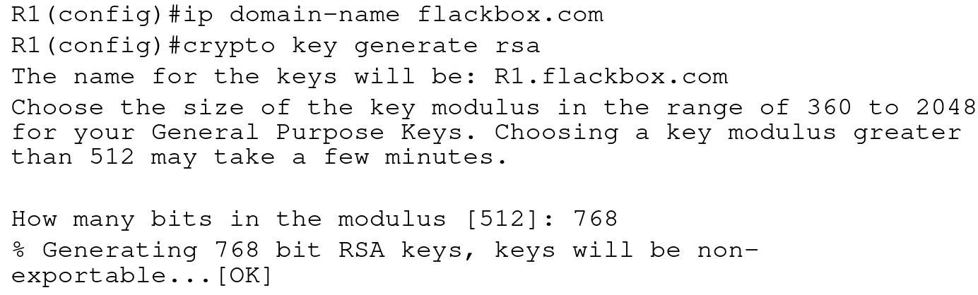

**Disable Telnet**

* VTY lines are used for both Telnet and SSH connections
* Access is allowed for both by default
* A username is required for SSH access (line level passwords are not supported)

*R1(config)#username Flackbox secret Flackbox1*

*R1(config)#line vty 0 15*

*R1(config-line)#transport input ssh (telnet not added)*

*R1(config-line)#login local (use local usernames)*

*R1(config-line)#exit*

*R1(config)#ip ssh version 2 (limit SSH to v2)*

# **AAA Server**

* Configuring line level security or local usernames on each device has a serious scalability limitation
* If a password has to be added, changed or removed it needs to be done on all devices
* An external AAA server can be used to centralise this instead
* Multiple AAA servers can be implemented for redundancy
* AAA servers provide Authentication, Authorization and Accounting.
* Authentication verifies somebody is who they say they are. This is most commonly achieved with a username and password.
* Authorization specifies what a particular user is allowed to do, such as running a particular command.
* Accounting keeps track of the actions a user has carried out.
* Authorization and Accounting are optional. Authentication is mandatory if Authorization and/or Accounting are used.

## **RADIUS and TACACS+**

* The protocols which are used for AAA services are RADIUS and TACACS+
* Both are open standards, although vendors may add their own proprietary extensions
* Many vendor’s AAA servers support both protocols
* RADIUS is commonly used for end user level services, such as VPN access
* TACACS+ is commonly used for administrator access on Cisco devices as it has more granular authorization capabilities

## **Cisco AAA Servers**

* Cisco’s AAA server is the Identity Services Engine (ISE)
* They also offered the Access Control Server (ACS) for a long time but it is now end of sale

## **Active Directory Integration**

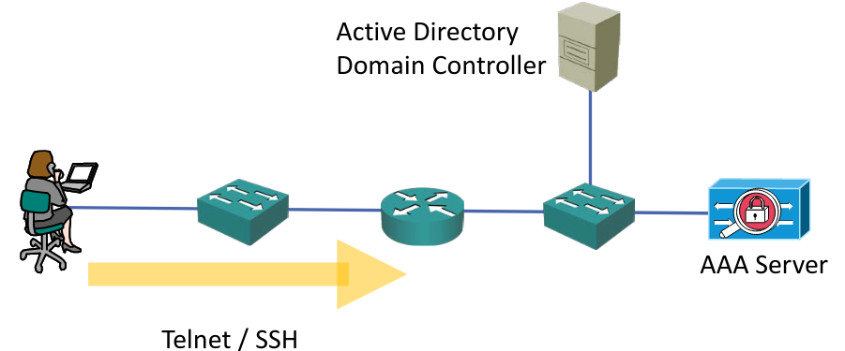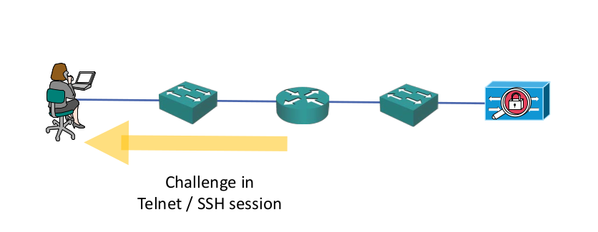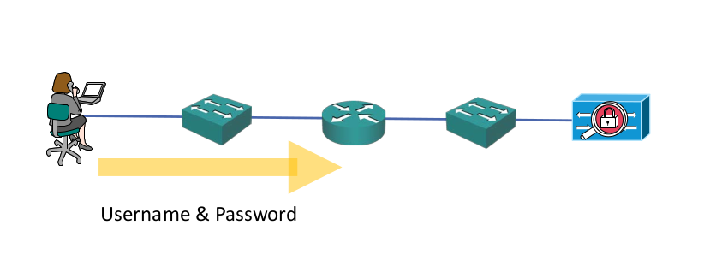

# 

# 

# **OR**

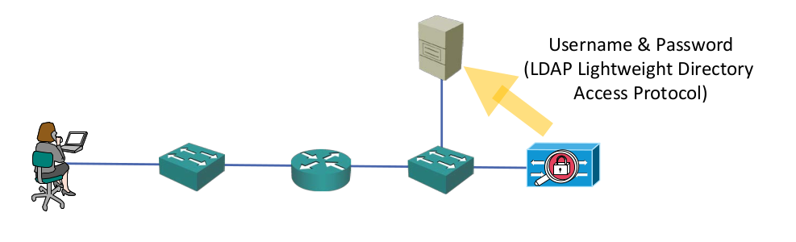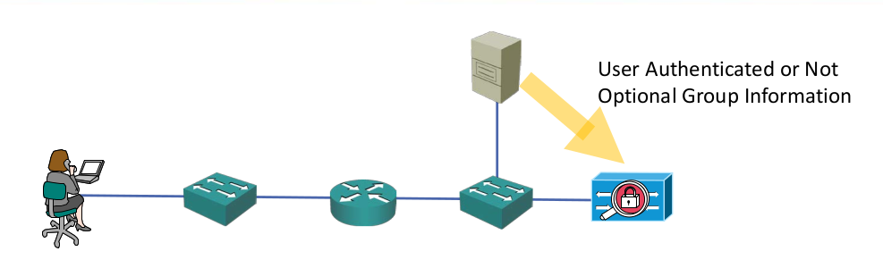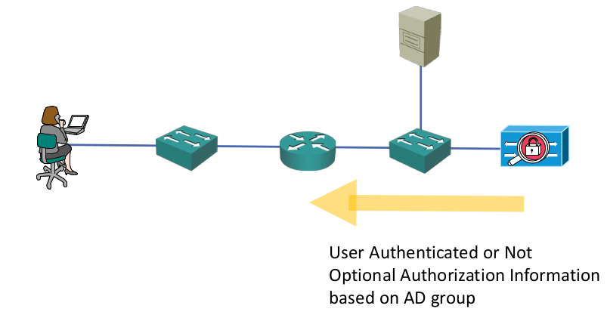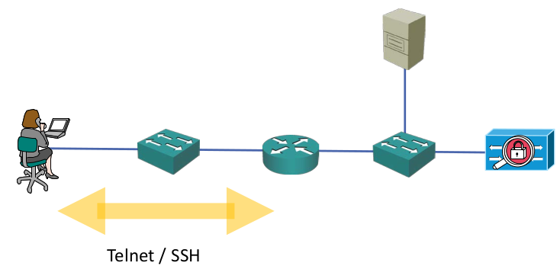

# **RADIUS/TACACS+ Configuration**

## **Old RADIUS Configuration**

*R1(config)#username BackupAdmin secret Flackbox1* (configure a local user in case connectivity to the AAA server is lost)

*R1(config)#aaa new-model*

*R1(config)#radius-server host 10.10.10.10 key Flackbox1*

*R1(config)#radius-server host 10.10.10.11 key Flackbox2*

*R1(config)#aaa group server radius FB-RG* (optional)

*R1(config-sg-radius)#server 10.10.10.10*

*R1(config-sg-radius)#server 10.10.10.11*

*R1(config)#aaa authentication login default group radius local*

(Use all RADIUS servers) OR:

*R1(config)#aaa authentication login default group FB-RG local*

(Use servers in specified group)

## **New RADIUS Configuration**

*R1(config)#radius-server host 10.10.10.10*

Warning: This CLI will be deprecated soon. Please move to radius server <name> CLI.

*R1(config)#aaa new-model*

*R1(config)#radius server Server1*

*R1(config-radius-server)# address ipv4 10.10.10.10*

*R1(config-radius-server)# key Flackbox1*

*R1(config)#radius server Server2*

*R1(config-radius-server)# address ipv4 10.10.10.11*

*R1(config-radius-server)# key Flackbox2*

*R1(config-radius-server)#aaa group server radius FB-RG*

*R1(config-sg-radius)# server name Server1*

*R1(config-sg-radius)# server name Server2*

*R1(config-sg-radius)#aaa authentication login default group FB-RG local*

## **Old TACACS+ Configuration**

*R1(config)#username BackupAdmin secret Flackbox1*

*R1(config)#aaa new-model*

*R1(config)#tacacs-server host 10.10.10.10 key Flackbox1*

*R1(config)#tacacs-server host 10.10.10.11 key Flackbox2*

*R1(config)#aaa group server tacacs+ FB-TG*

*R1(config-sg-tacacs+)#server 10.10.10.10*

*R1(config-sg-tacacs+)#server 10.10.10.11*

*R1(config)#aaa authentication login default group FB-TG local*

## **New TACACS+ Configuration**

*R1(config)#tacacs-server host 10.10.10.10*

Warning: This CLI will be deprecated soon. Please move to tacacs server <name> CLI.

*R1(config)#username BackupAdmin secret Flackbox1*

*R1(config)#aaa new-model*

*R1(config)#tacacs server Server1*

*R1(config-server-tacacs)# address ipv4 10.10.10.10*

*R1(config-server-tacacs)# key Flackbox1*

*R1(config)#tacacs server Server2*

*R1(config-server-tacacs)# address ipv4 10.10.10.11*

*R1(config-server-tacacs)# key Flackbox2*

*R1(config-radius-server)#aaa group server tacacs+ FB-TG*

*R1(config-sg-tacacs+)# server name Server1*

*R1(config-sg-tacacs+)# server name Server2*

*R1(config-sg-tacacs+)#aaa authentication login default group FB-TG local*

# **Best Practices**

## **Login and Exec Banners**

* Messages can be displayed in the CLI before and/or after an administrator logs in to a Cisco IOS device
* This is most commonly used to display security warnings

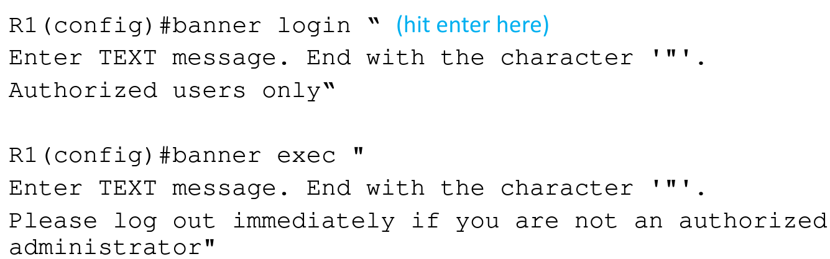

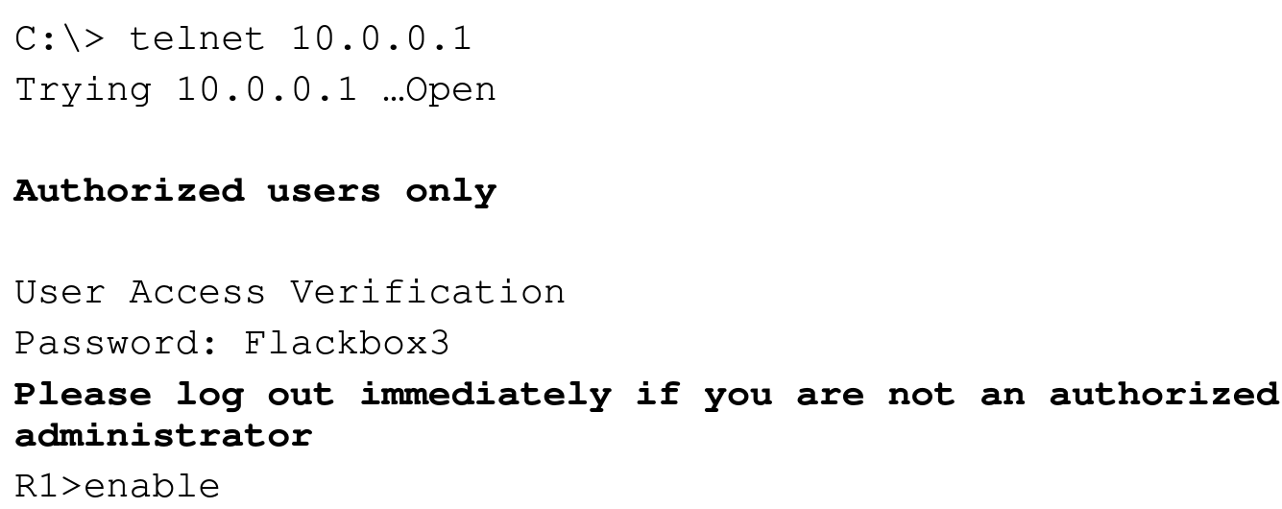

## **Disable Unused Services**

* It is best practice to disable unused services
* This reduces the attack surface and also the load on the device
* HTTPS is sometimes used by GUI administration tools but HTTP should be disabled
* CDP should also be disabled in highly secure environments

*R1(config)#no ip http server*

*R1(config)#no cdp run*

## **Time Synchronisation - NTP**

* All servers and infrastructure devices in your network should be synchronised to the same time
* This aids in troubleshooting as logs will report the correct time that events occurred
* It is also required by several security features such as Kerberos authentication and digital certificates

**NTP Network Time Protocol**

* Servers and infrastructure devices can use their own internal clock or synchronise with an external NTP server
* An NTP server should be used to ensure all devices have the same time
* A Cisco router can function as an NTP server and/or client

